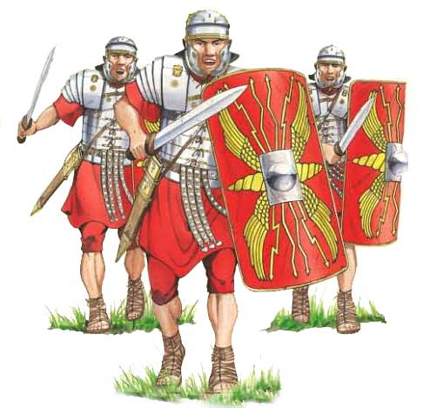Year 3 Home Learning Grid – Spring Term 2020
History Topic – The Romans
“I came, I saw, I conquered!” Julius Caesar.
This term, we are exploring 'The Romans' as our topic. We would like all Year 3 children to select their Home Learning from the grid below.
During each half term we would like to encourage all children to choose and complete two activities. Completed home learning can be brought into
school at any point in the term, although we would like to suggest that two pieces of home learning are submitted on or before
Wednesday 12th February 2020 and two further pieces of home learning are submitted on or before Wednesday 25th March 2020. All home learning will be celebrated in displayed either in the classroom or around school, so remember to use your best handwriting and carefully consider how you will present your learning.

Roman Entertainment  Create a model version of a Roman colosseum. | Roman Soldiers  1. Write a diary entry about a day in the life of a Roman soldier.  OR  2. Draw and label a diagram of a Roman soldier. | Celtic Living  Research Celtic living and what their homes were like. Design and label a Celtic round house.
Italian Food  Write instructions for making pizza. Remember to include an ingredients list and diagrams. | 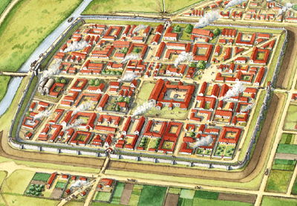Roman Town  Draw and design a Roman town. | Romulus and Remus  Retell the Roman myth of 'Romulus and Remus.' You could use pictures to help you.
Celtic Fact Sheet  Create an information report all about the Celtic way of life.  You could include; clothing, food, housing, hill forts, religion and weapons. | Roman Gods  Research Roman Gods. Present what you have found out in an exciting way. | Mosaics  Create a Roman mosaic, thinking carefully about colours, patterns and shapes.
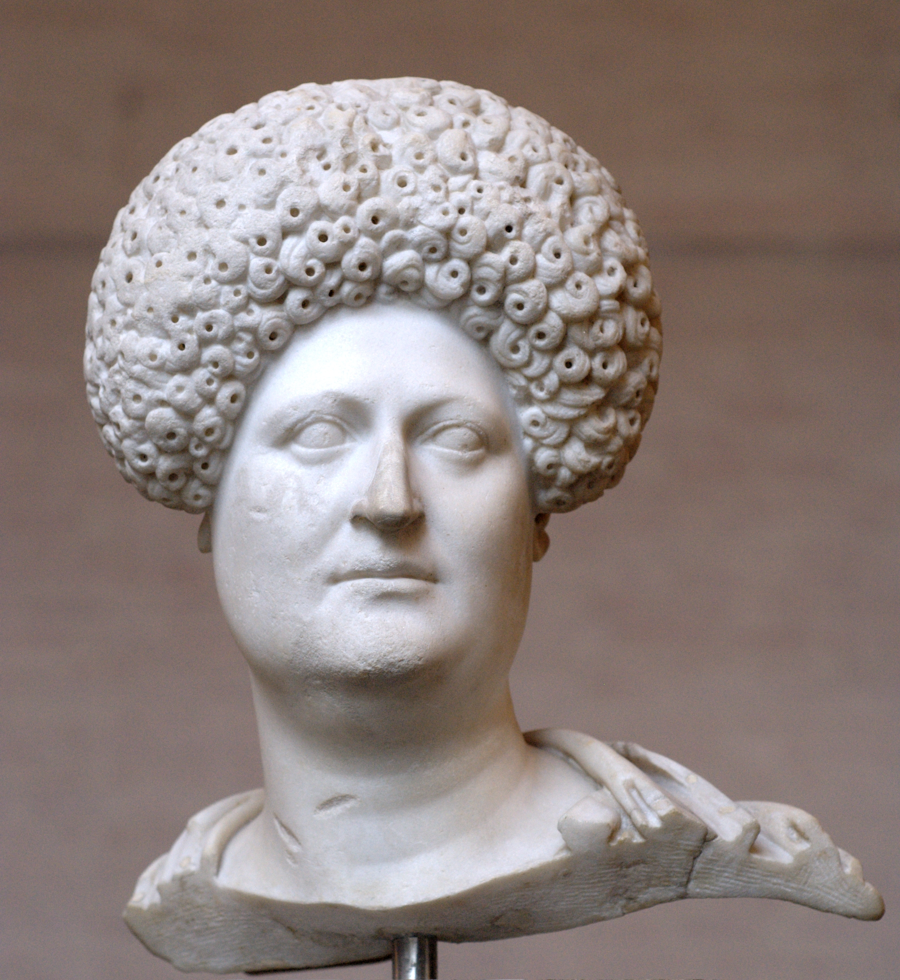Roman Bust  Sketch yourself as a Roman bust. | Queen Boudicca  Write a speech to the Celtic army from Queen Boudicca to encourage and persuade them to stand up and fight with her against the Roman army- what would she say? | Roman Numerals  1. Create secret number sentences and practise your Maths using Roman numerals. Can anybody in your class check your calculations?  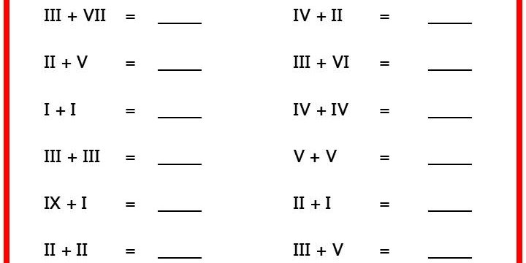  OR  2. Design/ make a clock using Roman numerals.

