**Spring spelling words to learn:**

|  |  |  |  |  |  |
| --- | --- | --- | --- | --- | --- |
| To be tested on… | | | | | |
| **17.01.2020** | **24.01.2020** | **31.01.2020** | **07.02.2020** | **14.02.2020** | **HALF TERM** |
| ancient | incredibly | steel | cereal | unfinished |
| appreciate | sensibly | steal | serial | infinitely |
| bruise | reliably | alter | father | unattached |
| guarantee | horribly | altar | farther | paragraph |
| hindrance | impossibly | led | guessed | geography |
| leisure | respectably | lead | guest | redefine |
| neighbour | agreeably | assent | morning | indefinable |
| pronunciation | enviably | ascent | mourning | incomplete |
| vehicle | adorably | bridal | who’s | constructively |
| yacht | acceptably | bridle | whose | exceptionally |

|  |  |  |  |  |  |
| --- | --- | --- | --- | --- | --- |
| **28.02.2020** | **06.03.2020** | **13.03.2020** | **20.03.2020** | **27.03.2020** | **EASTER** |
| led | thief | pierce | weigh | ceiling |
| lead | belief | fierce | receive | receive |
| steal | grief | friend | protein | received |
| steel | brief | patient | either | receipt |
| alter | piece | glacier | neither | deceit |
| altar | mischief | fiery | height | deceitful |
| assent | chief | view | eight | perceive |
| ascent | field | quiet | neighbour | conceit |
| are | shield | medieval | sovereign | conceited |
| our | priest | obedient | heir | inconceivable |

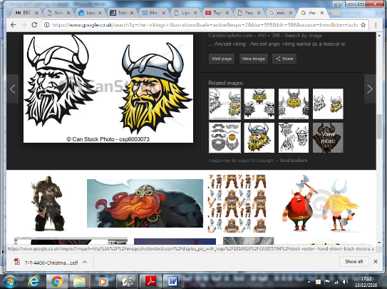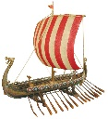**Year 5 Spring Home Learning**

This document details all home learning for the Spring Term (this is also available on the school website). Some home learning activities are compulsory and others voluntary.

**Compulsory:**

* Read to an adult 3 times per week (minimum, but ideally every day). Your adult should sign your diary after you have read.
* Learn weekly spellings using Spellodrome and any other strategies that you find helpful.
* Complete weekly Mathletics activities set.
* Home learning planners should be in and signed every Monday morning to confirm that compulsory home learning tasks have been completed.

**Voluntary:**

* Topic based tasks, which you can choose from, completed and brought into school to share. Some pieces will be displayed.

|  |  |  |
| --- | --- | --- |
| Vikings and Space voluntary home learning tasks: | | |
| Make a comic strip version of a Norse myth. | Make a model of a Viking house. | Write a poem about space and present it neatly for display. |
| Draw and label a Viking longship. | Write a job advertisement for a Viking warrior **eg**  Wanted – Viking Warrior  Must be able to…  Must be good at… | Create a model of the solar system. |
| Using the tune of a well-known song of your choice, make up your own song about the Vikings to teach the class. | Make a Viking God fact file. Include a picture for each God and some interesting facts. (You could use Power Point) | Design a poster explaining the phases of the moon. |
| Choose one of the countries that the Vikings were from (Denmark, Norway and Sweden).  Find out what the country is like today and make a leaflet to tell people about it. | Create an informative poster to tell your class about the Vikings. | Design a holiday brochure advertising earth as a wonderful place to visit. |

If you require resources, such as paper or card, please ask your Teacher.